**Nexus Aquarium**

*Developer Guide*

|  |  |  |
| --- | --- | --- |
| **Supervisor.** | **Miss Tooba** | |
| **Batch.** |  | |
| **Group.** | C | |
| **Serial No.** | **Enrollment Number** | **Student Name** |
| 1. | 123456 |  |
| 2. | 123456 |  |
| 3. | 123456 |  |
| 4. | 123456 |  |

1. **Home** (*index (1).html*)

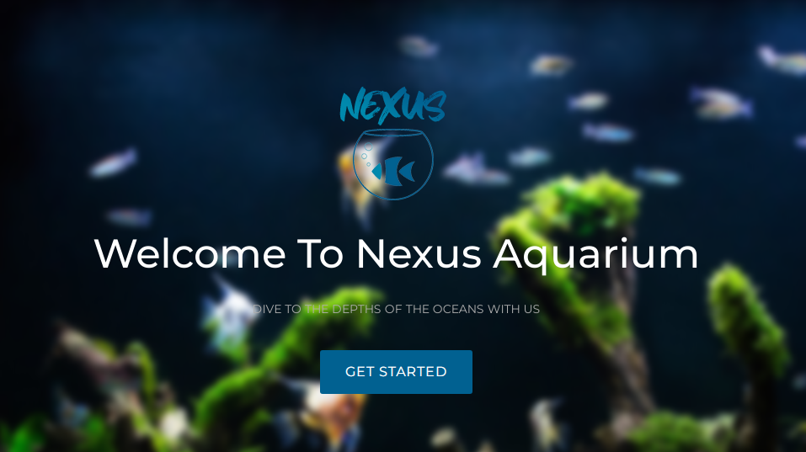

***Figure 1: Home page to Nexus aquarium***

 Our Slogan has given to the peoples toward our website. “DIVE TO THE DEPTHS OF THE OCEANS WITH US”.

* By clicking (**Get started**) button user while redirect to the main webpage.

**Code of Home page**

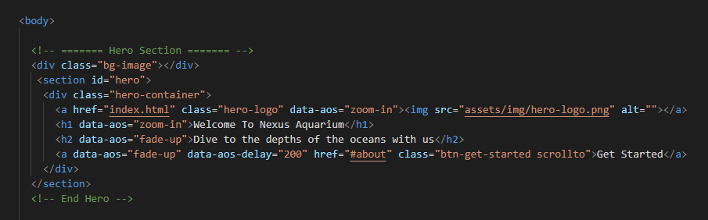

1. **Navbar (index (1).html)**



***Figure 2: Navbar***

We have given seven essentials. By clicking any of the essential’s and redirect to the linked page. (0. index (1).html)

**Code of Navbar**

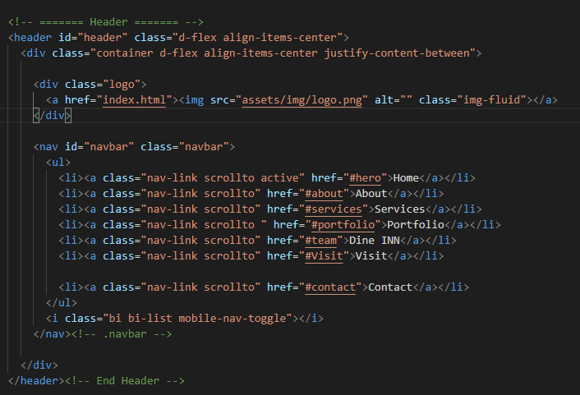

1. **About us (index (1).html)**



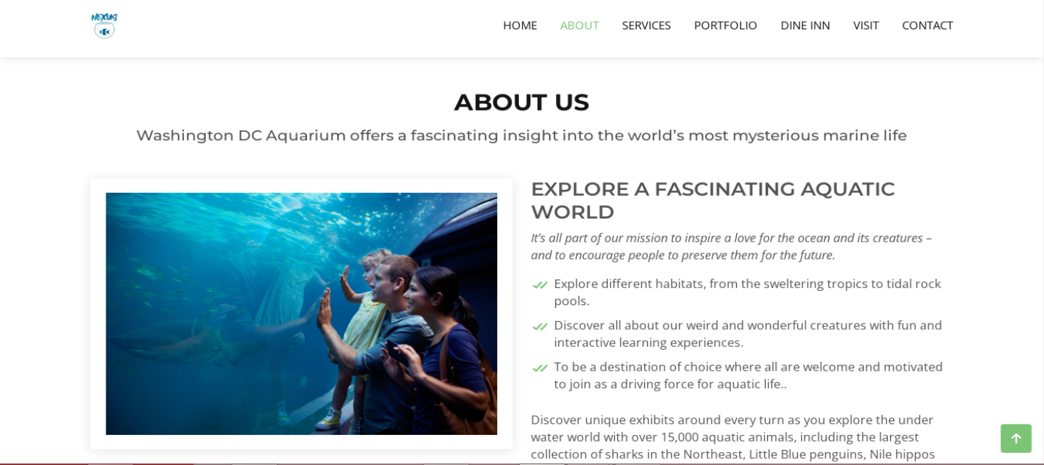

 ***Figure 3: About us***

**

* Explore different habitats, from the sweltering tropics to tidal rock pools.*

* Discover all about our weird and wonderful creatures with fun and interactive learning experience.*

* *To be a destination of choice where all are welcome and motivated to join as a driving force for aquatic life.*

***Code of About Us***

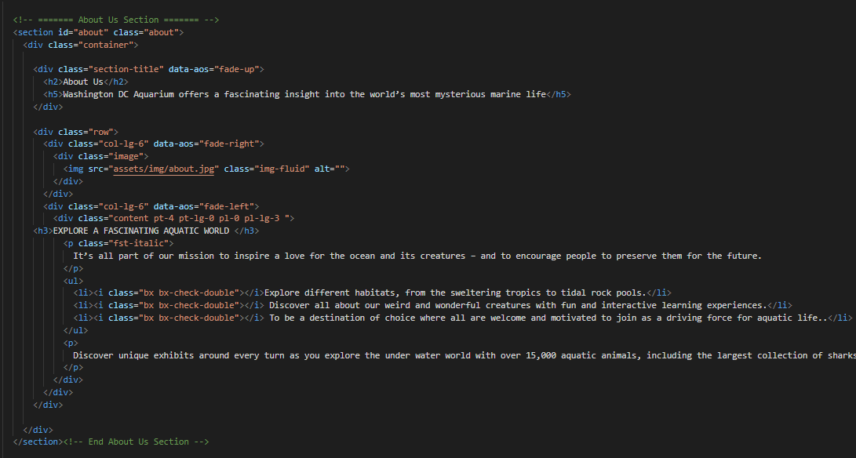

**Service (index (1).html)**

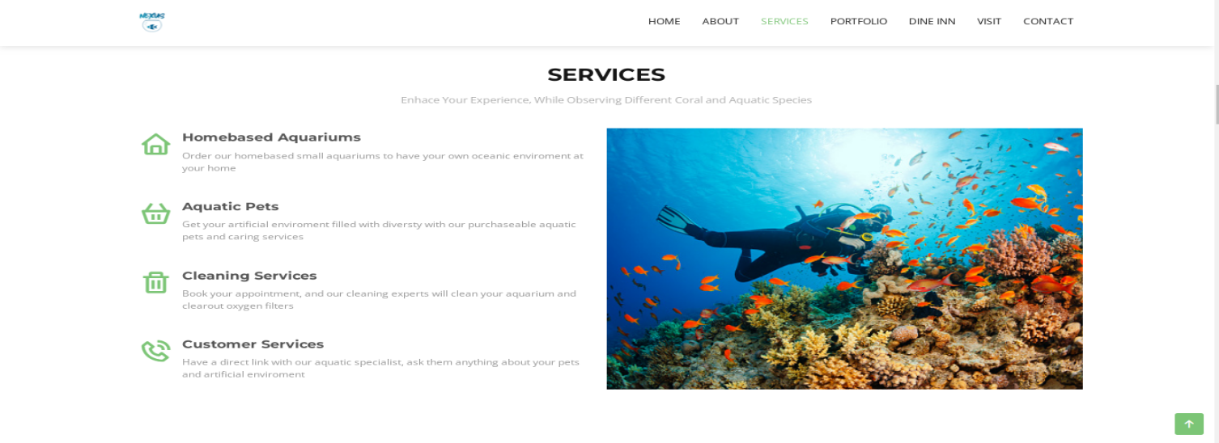

***Figure 4: Service***

*We have mentioned our basic services to make people known about the service we provide.*

** ***Home based Aquarium:*** *On our first service we have mentioned about providing home-based aquarium and providing them oceanic environment.*

* ***Aquatic pets:*** *We are giving idea about providing oceanic environment at home and we have mentioned how can be treat aquatic pets at home.*
* ***Cleaning Service:*** *We have mentioned that we are providing aquarium home cleaning services to the customer.*
* ***Customer Service:*** *For the ease of the people our website us providing customer service for the customer so that they can contact directly to our aquatic assistant*

***Code of Service***

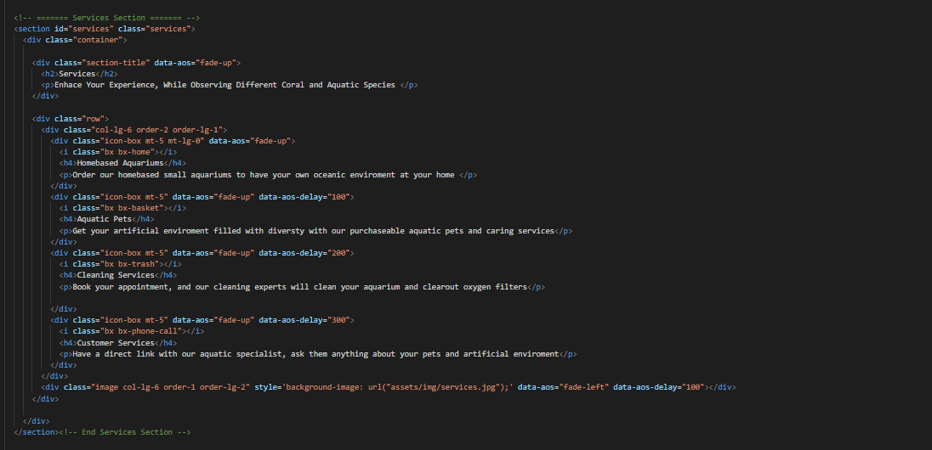

1. ***Mini Aquarium (index (1).html)***

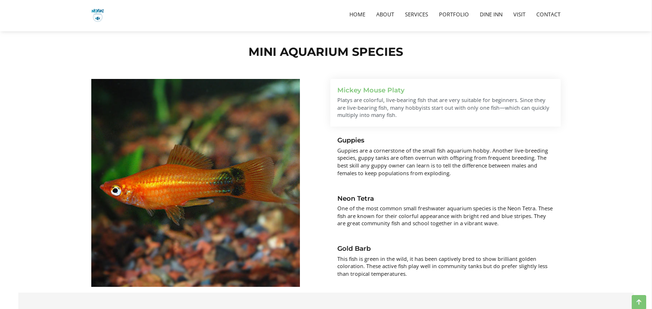



***Figure 5: Mini Aquarium Species***

***Description:*** *Every Aquarium have big tank and mini Aquarium for some unique and small types so species which can’t survive between big kind of marine.*

***“Description of some mini species”***

*We have given some unique kind of species in our mini Aquarium page*

*And provide hover to highlight the name and pictures so that people who are visiting our website can gain knowledge.*

* ***Mickey Mouse Platy***
* ***Guppies***
* ***Neon Tetra***
* ***Gold Barb***

***Code of Mini aquarium Species***

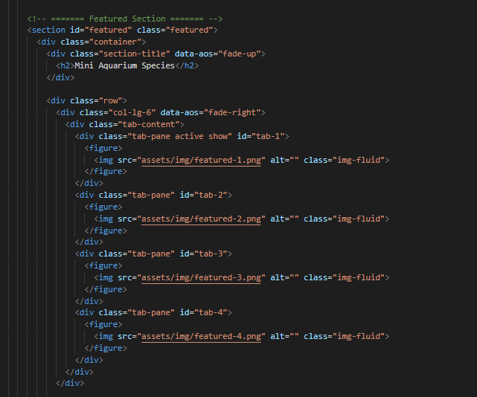

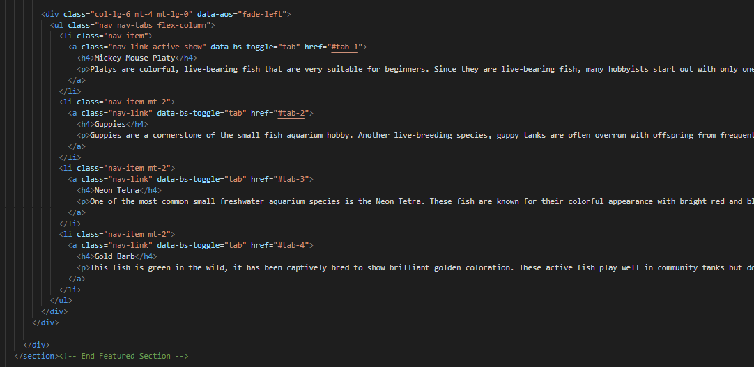

1. ***Menu bar:***

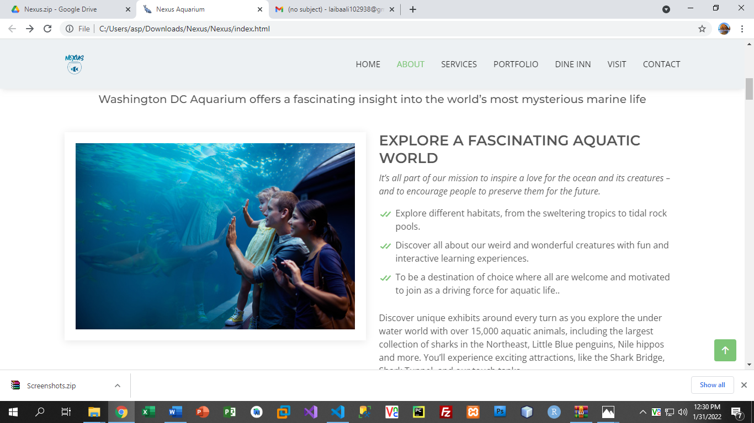

***Figure 6: Description of our Menu bar***

***Use to load the remaining sections. The following is a list of those sections:***

*As we have work on only single page and re-directing on other sections. So we are made our web directed pages.*

* ***Home Page (1. index (1).html)***
* ***About Page (2. index (1).html- About Section)***
* ***Services Page (3. index (1).html-Services Section)***
* ***Portfolio Page (4. index (1).html-Portfolio Section)***

*Portfolio details(5.Portfolio-detail.html)*

*Portfolio details(6.Portfolio-details-2.html)*

*Portfolio details(7.Portfolio-details-3.html)*

*Portfolio details(8.Portfolio-details-4.html)*

*Portfolio details(9.Portfolio-details-5.html)*

*Portfolio details(10.Octopus-details.html)*

*Portfolio details(11.Jellyfish-details.html)*

*Portfolio details(12.Beluga-details.html)*

*Portfolio details(13.Penguine-details.html)*

* ***Dine Inn Page (14. index (1).html)***
* ***Visit Page (15. index (1).html)***
* ***Contact Page (16. index (1).html***

1. ***Our Aquarium Video:***

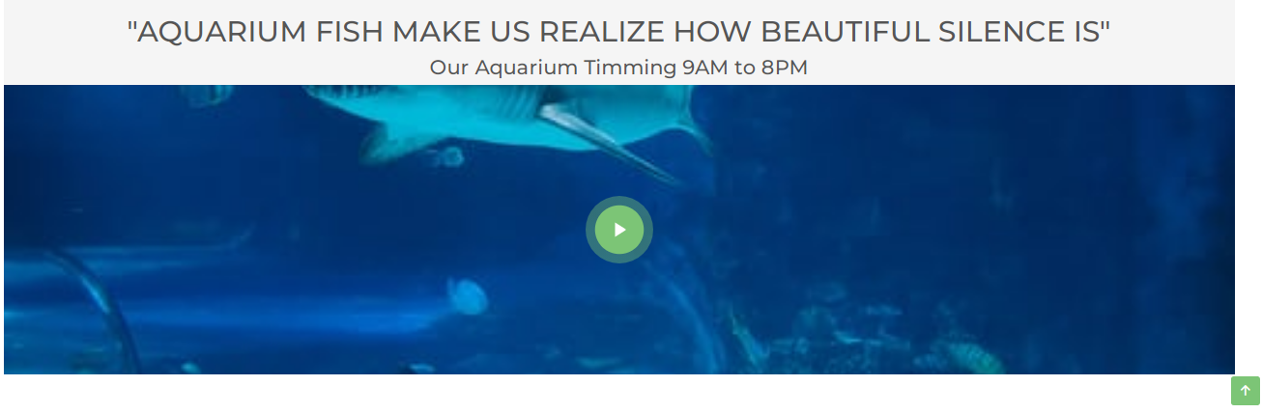

***Figure 7: Linked Video***

***We have put our Aquarium survey video link from YouTube for the attraction of client.***

***Code of Linked Video***

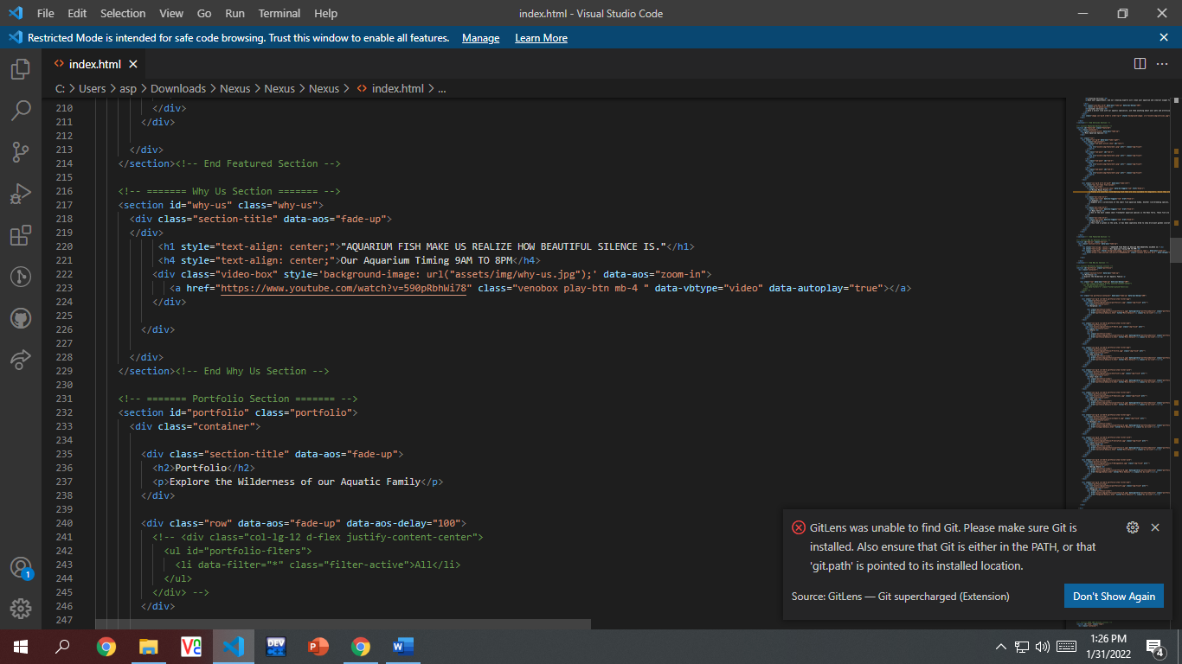

1. ***Portfolio (index (1).html):***

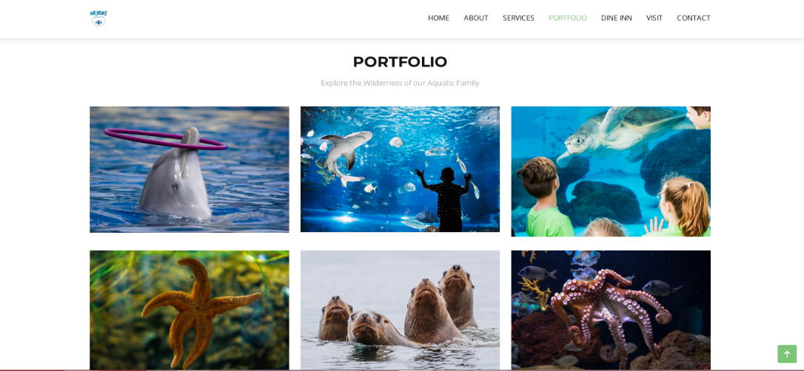

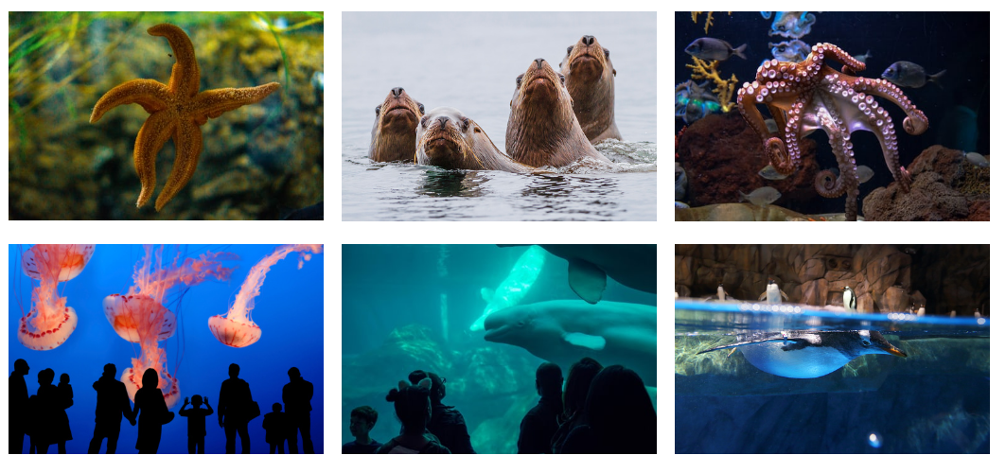

***Figure 8: Portfolio***

***Description:***

*In Portfolio we have specified about the specific marine animals and we have given the slide-show of the specific fishes to make our website creative and provide people knowledge about marines.*

*We have created the icon to redirect with the slideshow. We have given the details of the marine.*

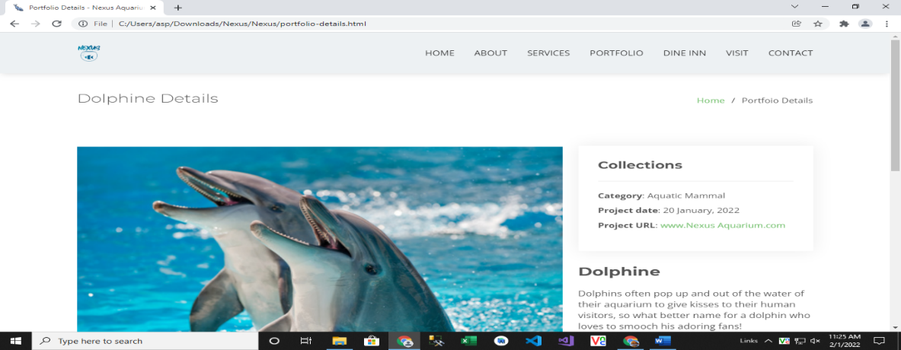

***Code of Portfolio***

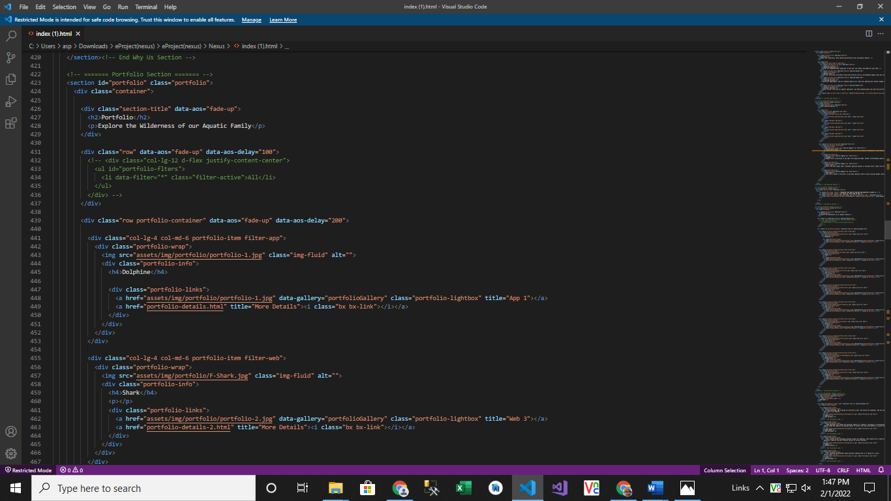

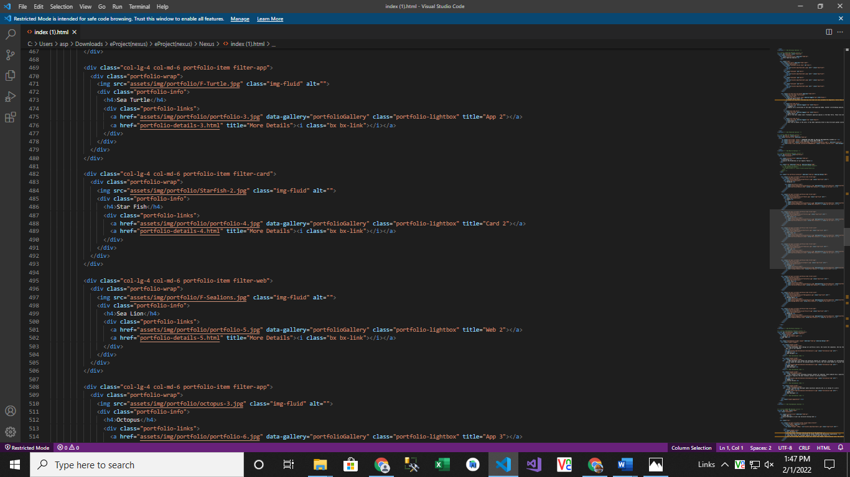

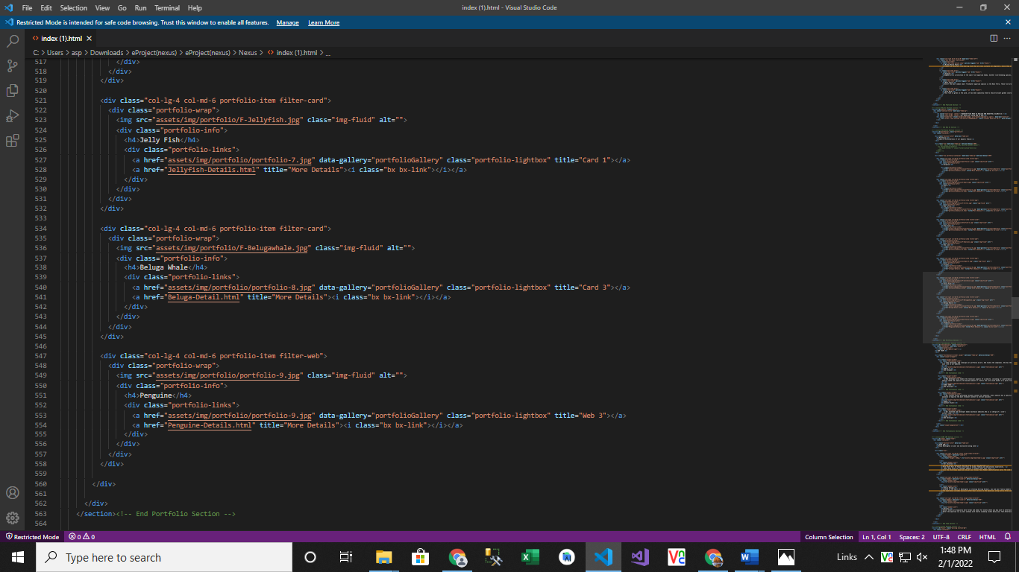

1. ***Our Team (index (1).html):***

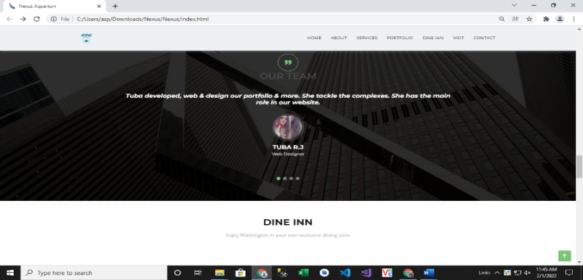



*Web Designer*

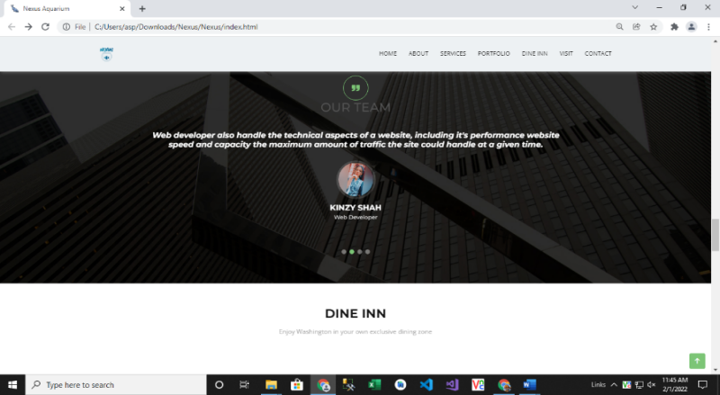



*Web Developer*

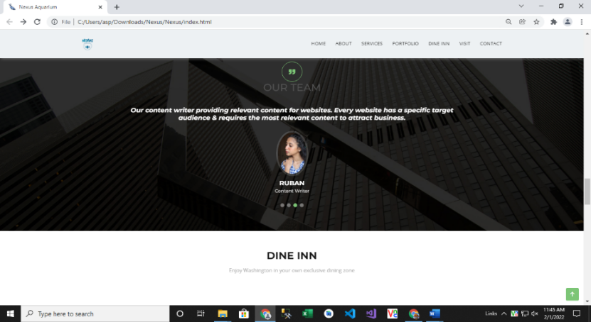



*Content Writer*

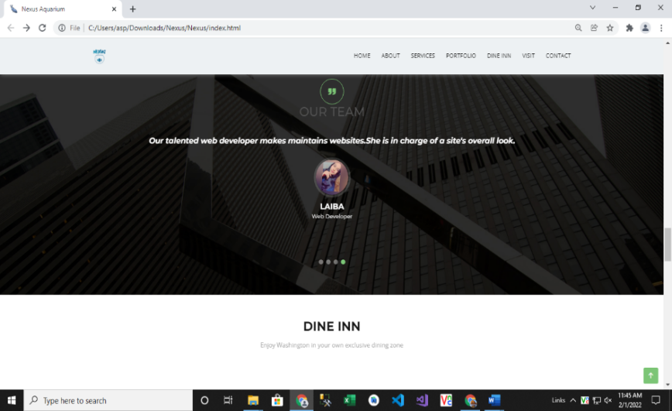



*Web Developer*

***Figure 9: Our Team***

***Code of Our Team***

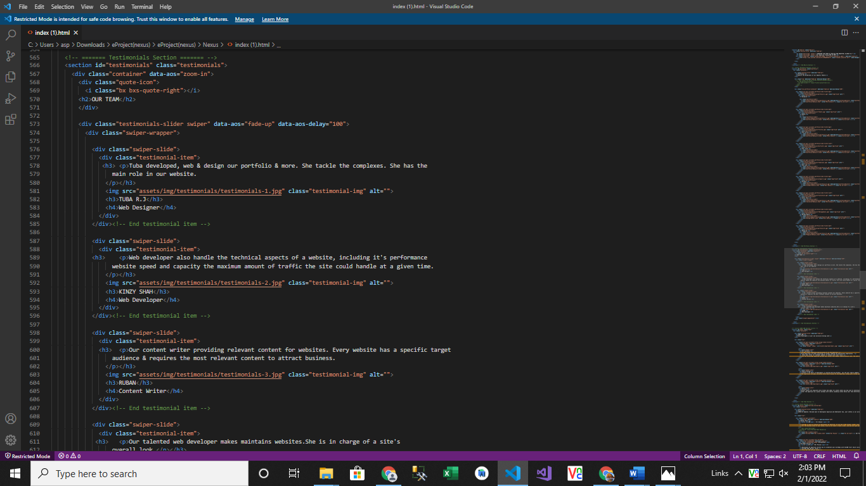



1. ***Dine Inn (index (1).html):***

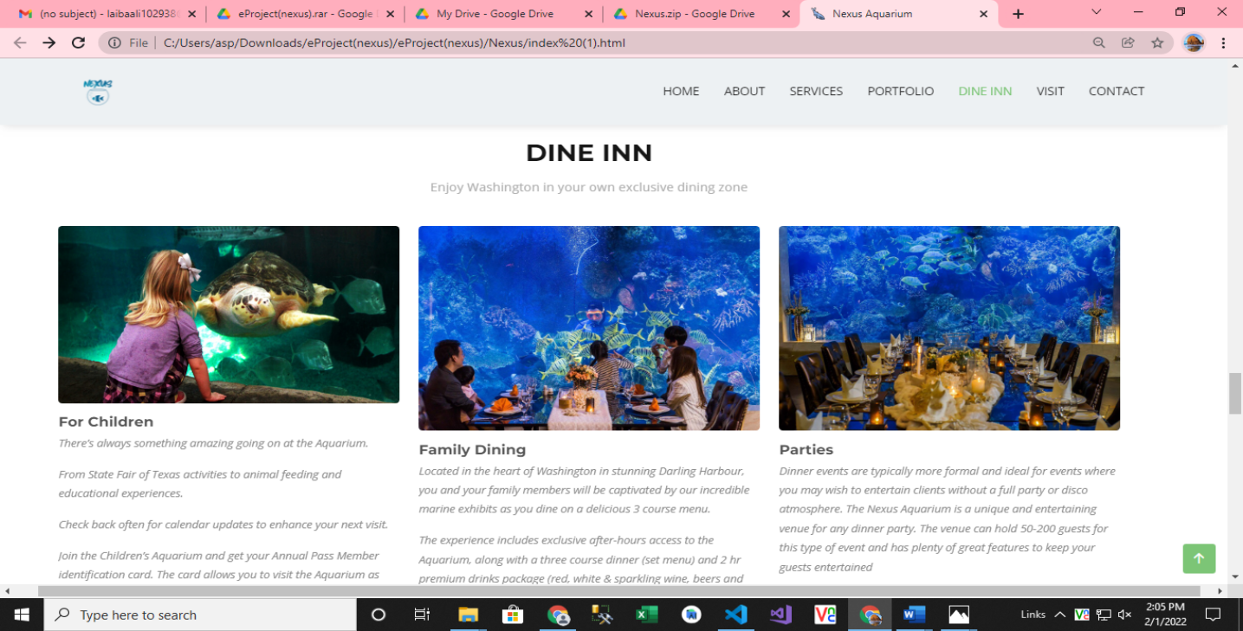

***Figure 10: Dine Inn***

Our dine inn page is designed to elaborate about our aquatic environment and our timings and other policies are also mentioned there.

***Code of Dine Inn***

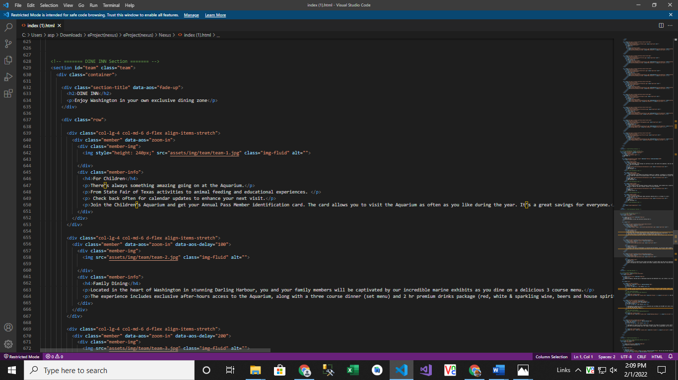

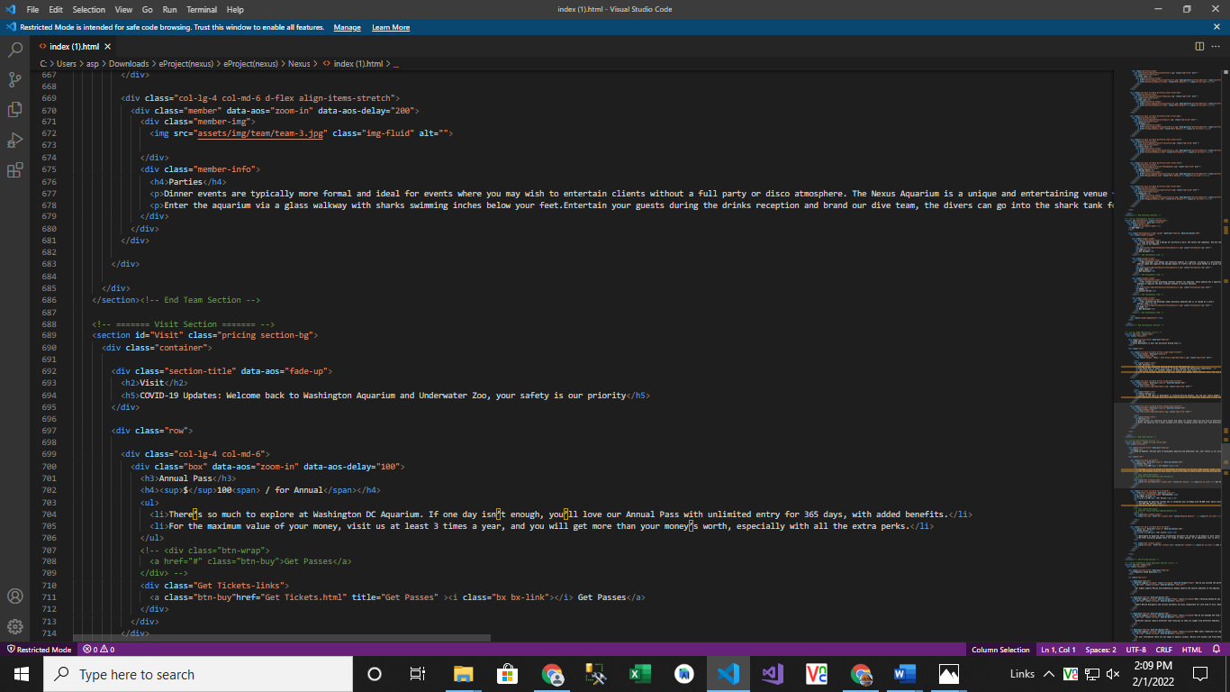

1. ***Visit (index 91).html):***

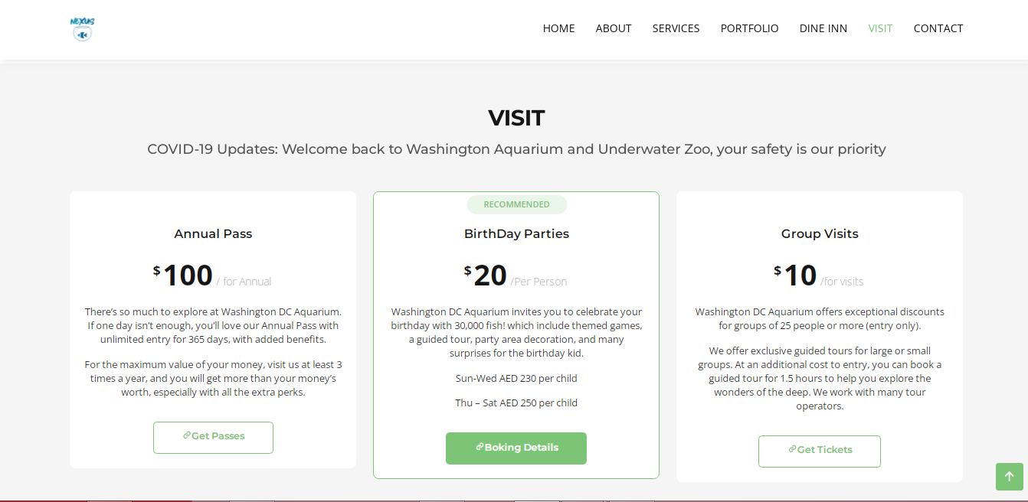

***Figure 11: Visit***

*Visit page is about individual charges for the aquarium visit and basics description for parties and group visit.*

*We have given hover and link to re-direct to the ticket form for booking.*

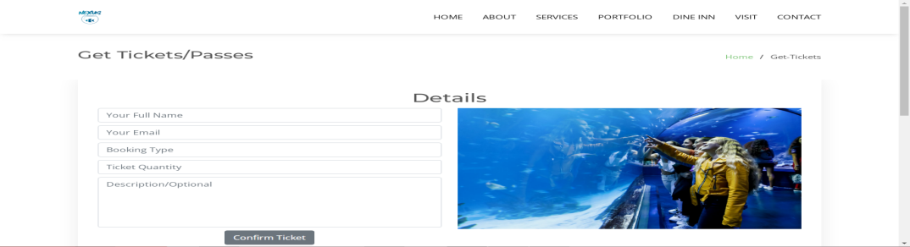

*Ticket Form:*

In ticket forms customer have to give details:

Your Full Name: Customer have to write their full name.

Your Email: Email won't be accepted without @ we have given validations.

Booking Type: In booking type the person have to mention about what type of passes they want to confirm.

Ticket Quantity: Number of tickets they want to confirm.

Description: Description is optional but if they want to mention any validation or request about something they can write there.

***Code of Visit***

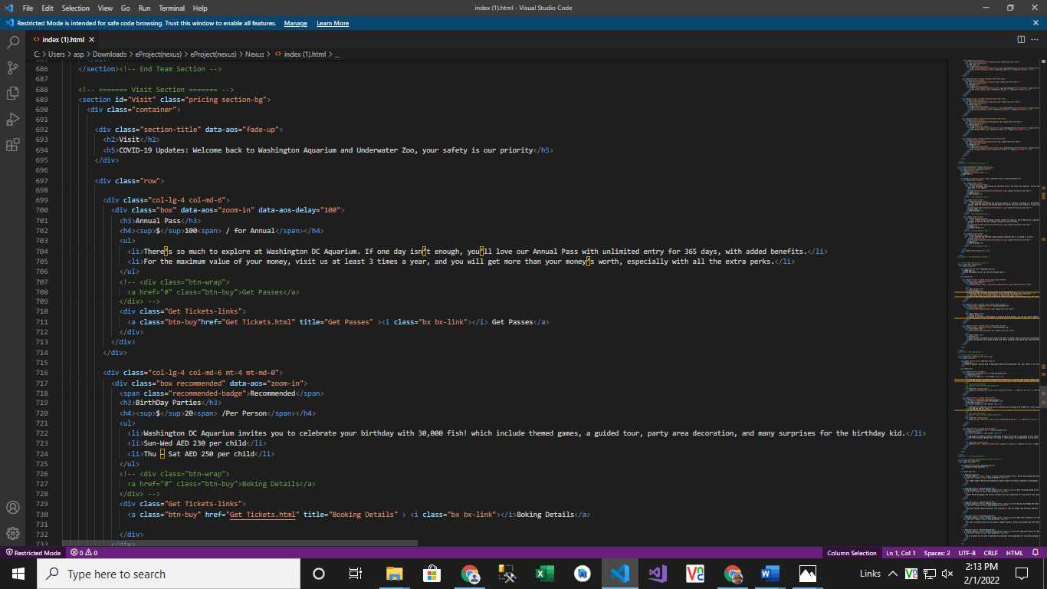

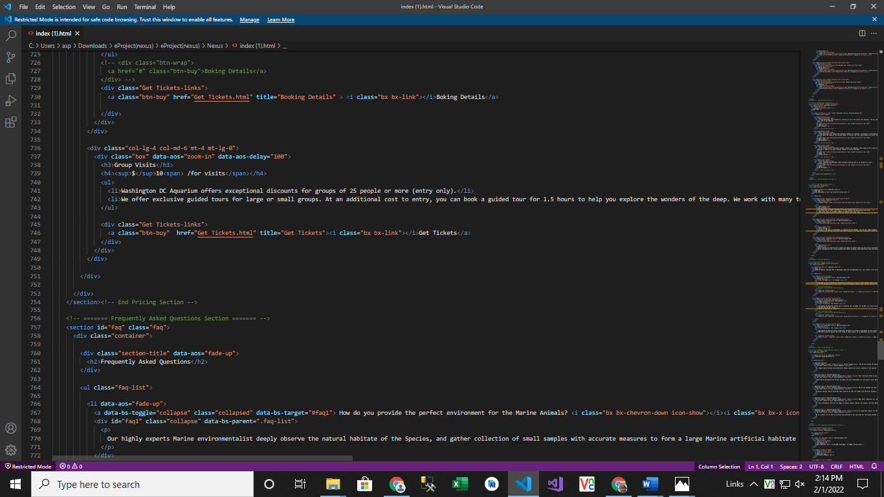

1. ***Questions About Aquarium (index (1).html):***

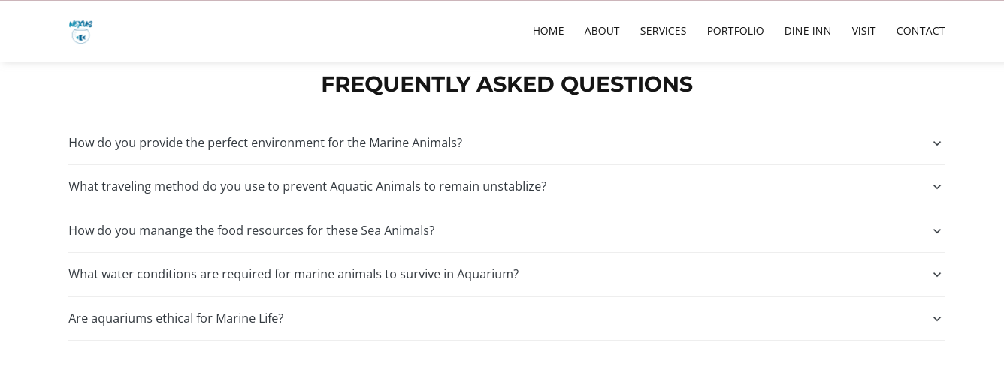

***Figure 12: Questions about Aquarium***

If any client has any query about our marine aquarium so they can have solutions over here.

***Code of Questions***

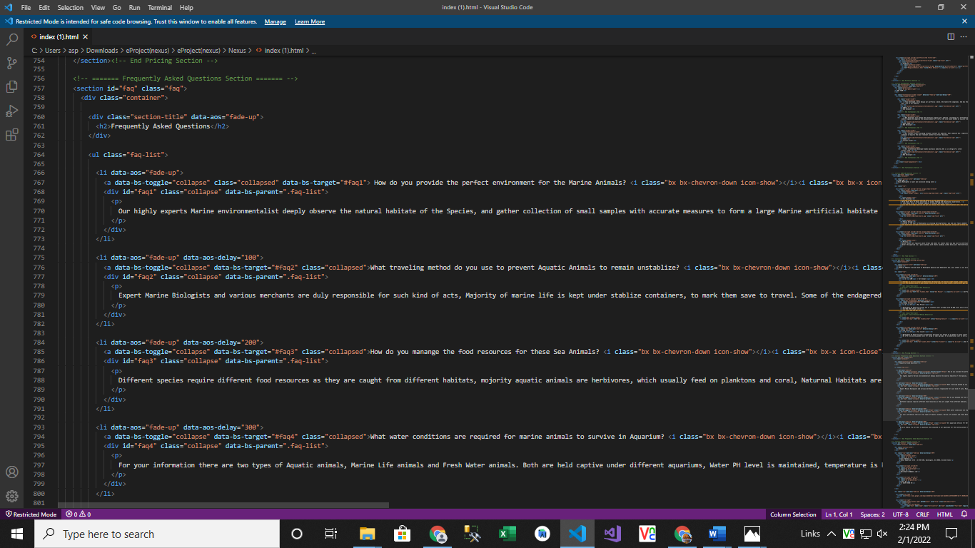

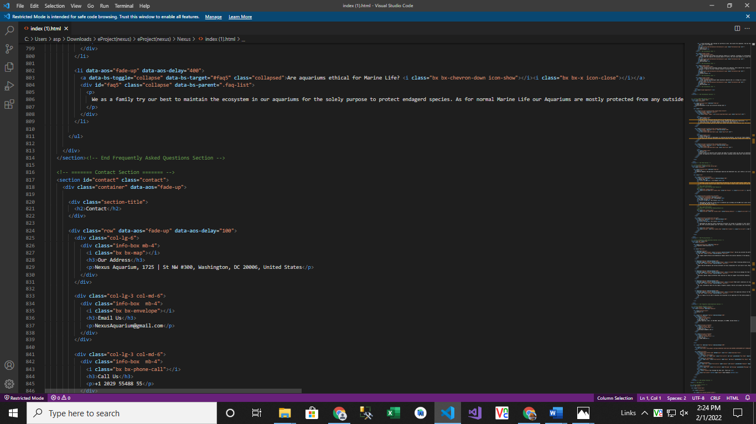

1. ***Contact (index (1).html):***

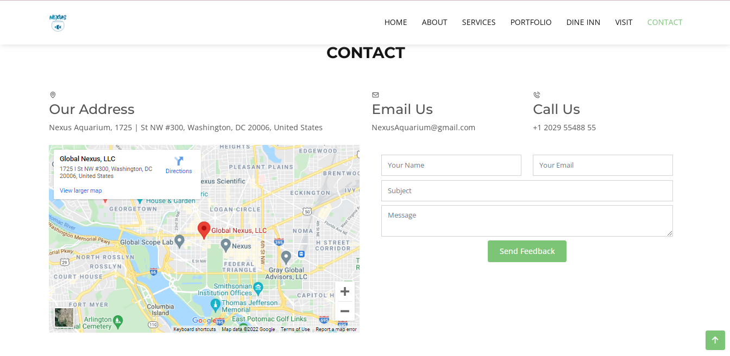

***Figure 13: Contact***

*In our contact section we have given location map for the ease of the people*

*Email id and phone number for contacting in case of any problem.*

*Feedback Form:*

*To know the response of the people our team has given feedback page for the ideas and feedback of the people.*

***Code of Contact***

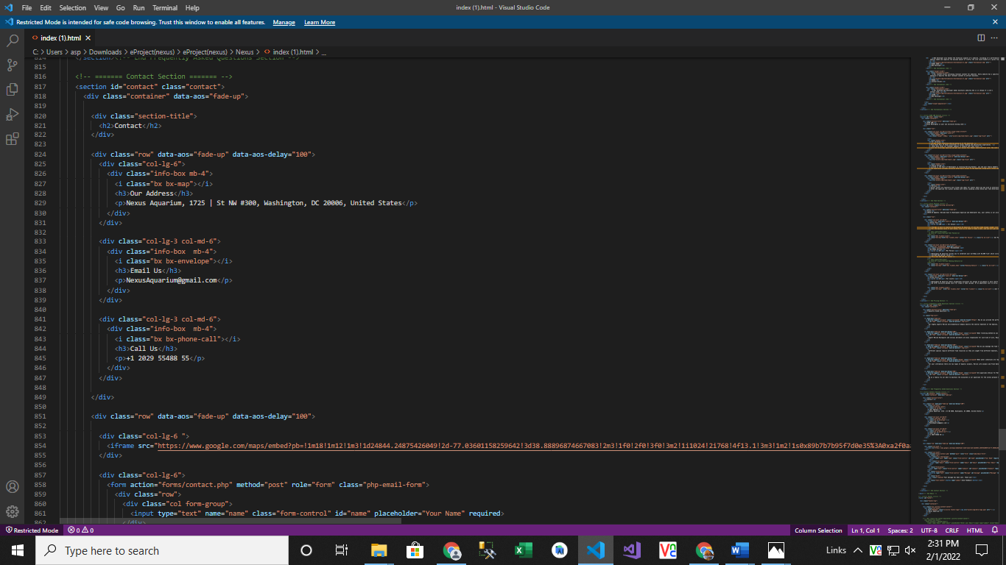

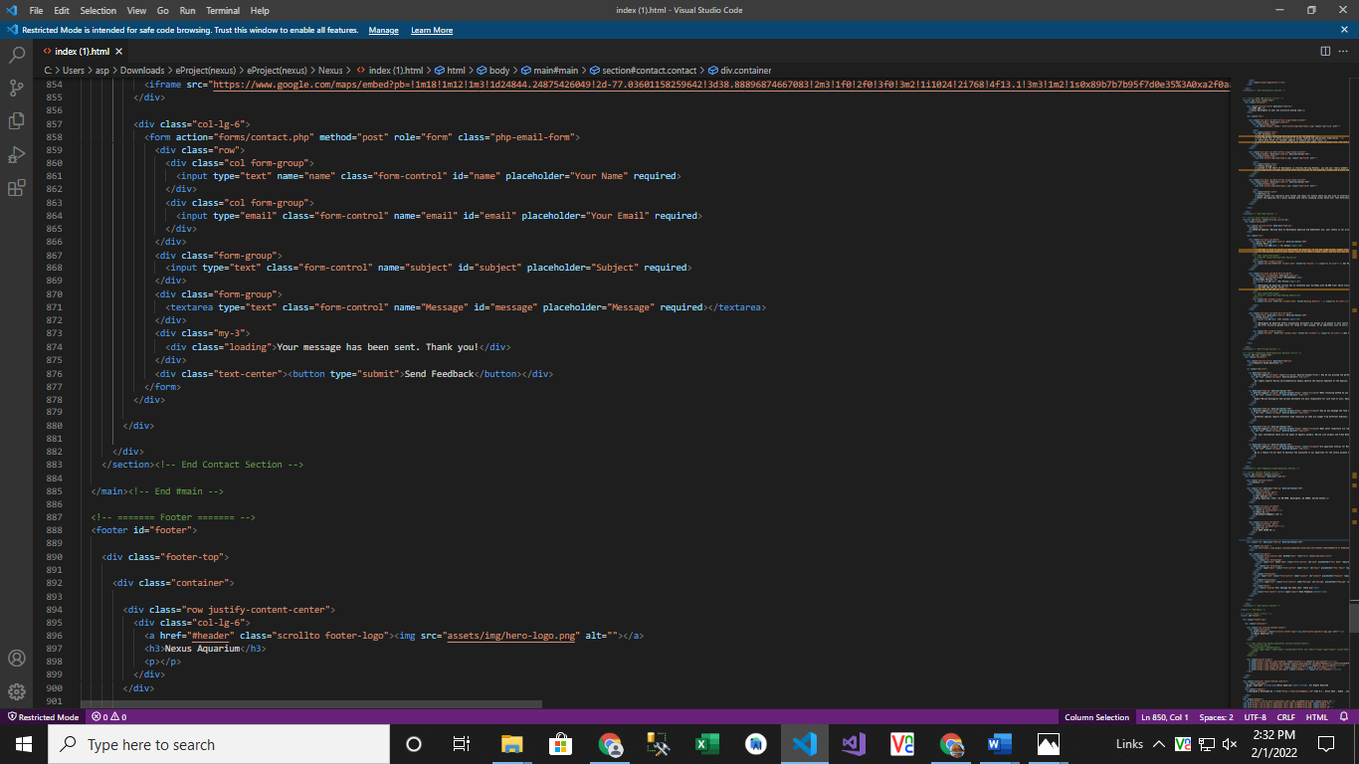

1. ***Inner Page(inner.html):***

***Figure 14: Footer***

We have given some water bubbles animations in footer to make our website more relaxing. Copyrights are given in the end of the website and effects of Facebook Instagram and twitter are also mentioned for making the website attractive